**Data Structures using C (Lab-File)**

**Name: Janak Pandey**

**Roll No: 24/SCA/BCA/066**

**Class: 2-B**

**Course: BCA**

**Array**

An **array** is a linear data structure that stores data of similar types under a single name in a contiguous memory location.

**// 1. Program to demonstrate insertion and output in an array:**

#include <stdio.h>

int main(){

int arr[5];

**//Array Insertion.**

printf("Enter the elements in array: \n");

for(int i = 0; i<5; i++){

scanf("%d", &arr[i]);

}

**//Output from an array.**

printf("\n The elements that you have enterd are: ");

for(int i = 0; i<5; i++){

printf("%d ", arr[i]);

}

return 0;

}

**Output:**

**// 2. Program to demonstrate searching in an array:**

#include <stdio.h>

int main() {

int arr[] = {10, 20, 30, 40, 50};

int size = sizeof(arr) / sizeof(arr[0]);

int key, found = 0;

printf("Enter the element to search: ");

scanf("%d", &key);

for (int i = 0; i < size; i++) {

if (arr[i] == key) {

printf("Element %d found at index %d.\n", key, i);

found = 1;

break;

}

}

if (found == 0) {

printf("Element %d not found in the array.\n", key);

}

return 0;

}

**Output:**

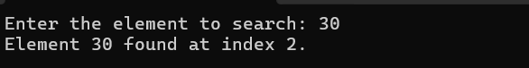

**// 3. Program to demonstrate sorting in an array:**

#include <stdio.h>

int main(){

int arr[5] = {1,7,3,6,4};

int temp;

for(int i = 0; i<5; i++){

for(int j = 0; j<4; j++){

if(arr[j] > arr[j + 1]){

temp = arr[j];

arr[j] = arr[j + 1];

arr[j + 1] = temp;

}

}

}

printf("Ascending order: \n");

for(int i = 0; i<5; i++){

printf("%d ", arr[i]);

}

}

**Output:**

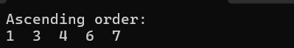

**Stacks**

Stack is a linear data structure that follows the LIFO (Last –In-First-Out) method. It means that the last data element to be inserted in the stack will be the first to come out.

There are two **operations on Stack**. They are:

1. **Push**: It is used to insert an element into the stack.
2. **Pop**: It is used to remove an element from the stack.

**// 1. Program to demonstrate** **PUSH() and** **POP() operations in the stack:**

#include<stdio.h>

#define Max 5 **//Max size of the stack.**

**//Structure of the stack.**

struct Stack{

int data[Max];

int top;

};

struct Stack s; **//Initializing the stack.**

**//Declaring Functions**

void PUSH(int n);

void POP();

void PRINT();

**//Program execution starts from here.**

int main(){

s.top = -1;

POP();

PUSH(10);

PUSH(20);

PUSH(30);

PUSH(40);

PUSH(50);

PUSH(60);

POP();

PRINT();

return 0;

}

**// 1.1. Function to insert an element into the stack.**

void PUSH(int n){

if(s.top == Max-1){

printf("Stack is full.\n\n");

return;

}

s.data[++s.top] = n;

printf("%d pushed into the stack\n\n", n);

}

**// 1.2. Function to remove an element from the stack.**

void POP(){

if(s.top == -1){

printf("Stack is empty\n\n");

return;

}

int value = s.data[s.top--];

printf("%d removed from the stack\n\n", value);

}

**// 1.3. Function to traverse and print all the elements in the stack.**

void PRINT(){

if(s.top == -1){

printf("Stack is empty\n\n");

return;

}

printf("Elements in the stack:\n");

for(int i=0; i<=s.top; i++){

printf("%d\t", s.data[i]);

if(i==s.top){

printf("\n\n");

}

}

}

**Output:**

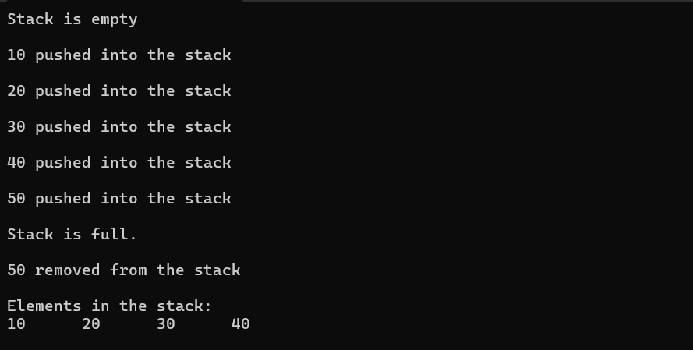

**Queue**

A **queue** is a linear data structure that stores data in **FIFO** (First-In-First-Out) order. It means that the first element to be inserted in the queue will also be the first element to come out.

The **operations we can perform on a queue** are:

1. **Enqueue**: To insert an element in the queue.
2. **Dequeue**: To remove an element from the queue.

**// 1. Program to demonstrate ENQUEUE () and DEQUEUE () operations in a queue:**

#include<stdio.h>

#define Max 5

**//Structure of a queue.**

struct Queue{

int data[Max];

int front;

int rear;

};

struct Queue q; **//Initializing a queue.**

**//Declaring functions.**

void ENQUEUE(int n);

void DEQUEUE();

void PRINT();

**//Program execution starts from here.**

int main(){

q.front = -1;

q.rear = -1;

DEQUEUE();

ENQUEUE(10);

ENQUEUE(20);

ENQUEUE(30);

ENQUEUE(40);

ENQUEUE(50);

ENQUEUE(60);

DEQUEUE();

PRINT();

return 0;

}

**// 1.1 Function to insert an element in the queue.**

void ENQUEUE(int n){

if(q.rear == Max-1){

printf("Queue is full\n\n");

return;

}

q.data[++q.rear] = n;

printf("%d inserted in the queue\n\n", n);

}

**// 1.2. Function to remove an element from a queue.**

void DEQUEUE(){

if(q.rear == q.front){

printf("Queue is empty\n\n");

q.front = -1;

q.rear = -1;

return;

}

int value = q.data[++q.front];

printf("%d removed from the queue\n\n", value);

}

**// 1.3. Function to traverse and display all the elements in the queue.**

void PRINT(){

if(q.front == q.rear){

printf("Queue is empty\n\n");

return;

}

for(int i=q.front+1; i<=q.rear; i++){

printf("%d\t", q.data[i]);

if(i==q.rear){

printf("\n\n");

}

}

}

**Output:**

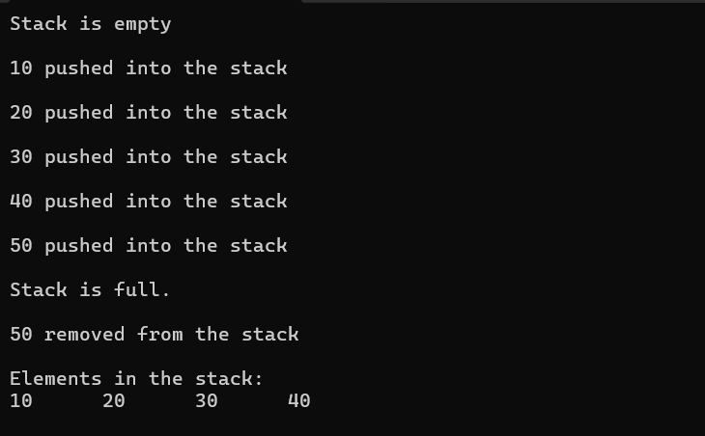

**Circular Queue**

A **circular queue** is a type of queue in which the last element of the queue is connected to the first element of the queue, making a circular chain.

**// 1. Program to implement circular queue and operations on it.**

#include <stdio.h>

#define MAX 5

struct Queue {

int data[MAX];

int front;

int rear;

};

struct Queue q = {.front = -1, .rear = -1};

**// 1.1. Function to insert element into the circular queue**

void ENQUEUE(int value) {

if ((q.rear + 1) % MAX == q.front) {

printf("Queue is full\n");

return;

}

if (q.front == -1) {

q.front = 0;

}

q.rear = (q.rear + 1) % MAX;

q.data[q.rear] = value;

printf("%d inserted into the queue\n", value);

}

**// 1.2. Function to remove element from the circular queue**

void DEQUEUE() {

if (q.front == -1) {

printf("Queue is empty\n");

return;

}

int value = q.data[q.front];

if (q.front == q.rear) {

**// Only one element in queue**

q.front = -1;

q.rear = -1;

} else {

q.front = (q.front + 1) % MAX;

}

printf("%d removed from the queue\n", value);

}

**// 1.3. Function to display the elements of the queue**

void DISPLAY() {

if (q.front == -1) {

printf("Queue is empty\n");

return;

}

printf("Queue elements: ");

int i = q.front;

while (1) {

printf("%d ", q.data[i]);

if (i == q.rear) break;

i = (i + 1) % MAX;

}

printf("\n");

}

**// Main function to test the queue**

int main() {

ENQUEUE(10);

ENQUEUE(20);

ENQUEUE(30);

ENQUEUE(40);

ENQUEUE(50); **// Will say "Queue is full" because one slot is always kept empty.**

DISPLAY();

DEQUEUE();

DEQUEUE();

DISPLAY();

ENQUEUE(60);

ENQUEUE(70);

DISPLAY();

return 0;

}

**Output:**

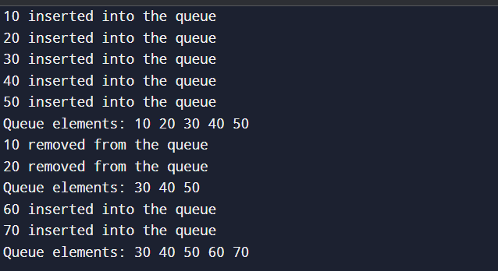

**Linked List**

A **linked list** is a linear data structure that uses nodes to store the data, and each node is connected to another node via pointers.

We can perform various operations on a linked list such as:

1. Insertion at beginning.
2. Insertion at end.
3. Insertion at specific position.
4. Deletion from beginning.
5. Deletion form end.
6. Deletion from a specific position.

**// 1. Program to show the implementation of a linked list and its operations.**

#include<stdio.h>

#include<stdlib.h>

**//Structure of a Node.**

struct Node{

int data;

struct Node* next;

};

**//Declaring functions.**

void insertAtBeginning(Node** pointerToHead, int x);

void insertAtEnd(Node** pointerToHead, int x);

void insertAt(Node** pointerToHead, int pos, int x);

void deleteFromFirst(Node** pointerToHead);

void deleteFromEnd(Node** pointerToHead);

void deleteFrom(Node** pointerToHead, int pos);

void Print(Node* head);

**//Execution of program starts from here.**

int main(){

struct Node* head = NULL;

insertAtEnd(&head, 20);

insertAtBeginning(&head, 10);

insertAtBeginning(&head, 30);

insertAt(&head, 1, 70);

insertAt(&head, 4, 80);

insertAt(&head, 5, 90);

insertAtEnd(&head, 100);

deleteFrom(&head, 1);

deleteFrom(&head, 4);

deleteFrom(&head, 5);

deleteFromFirst(&head);

deleteFromEnd(&head);

Reverse(&head);

Print(head);

}

**// 1.1. Insert a node at the beginning.**

void insertAtBeginning(Node** pointerToHead, int x){

struct Node* newNode = (struct Node*)malloc(sizeof(struct Node));

newNode -> data = x;

newNode -> next = *pointerToHead;

*pointerToHead = newNode;

}

**// 1.2. Insert a node at the end.**

void insertAtEnd(Node** pointerToHead, int x){

struct Node* newNode = (struct Node*) malloc(sizeof(struct Node));

newNode -> data = x;

newNode -> next = NULL;

if(*pointerToHead == NULL){

*pointerToHead = newNode;

}

else{

struct Node* endNode = *pointerToHead;

while(endNode -> next != NULL){

endNode = endNode -> next;

}

endNode -> next = newNode;

}

}

**// 1.3. Insert a node at nth position.**

void insertAt(Node** pointerToHead, int pos, int x){

if(pos<1){

printf("Invalid Position\n");

return;

}

struct Node* newNode = (struct Node*)malloc(sizeof(struct Node));

newNode -> data = x;

if(pos == 1){

newNode -> next = *pointerToHead;

*pointerToHead = newNode;

return;

}

struct Node* current = *pointerToHead;

for(int i=1; i<pos-1 && current!=NULL; i++){

current = current -> next;

}

if(current == NULL){

printf("Invlalid position\n");

free(newNode);

return;

}

newNode -> next = current -> next;

current -> next = newNode;

}

**// 1.4. Delete a node from nth position.**

void deleteFrom(Node** pointerToHead, int pos){

if(*pointerToHead == NULL || pos<1){

printf("Invalid position or empty list\n");

return;

}

if(pos == 1){

Node* temp = *pointerToHead;

*pointerToHead = (*pointerToHead)-> next;

free(temp);

return;

}

Node* current = *pointerToHead;

for(int i=1; i<pos-1 && current != NULL; i++){

current = current -> next;

}

if(current == NULL || current -> next == NULL){

printf("Invalid position\n");

return;

}

Node* temp = current -> next;

current -> next = current -> next -> next;

free(temp);

}

**// 1.5. Delete a node from first position.**

void deleteFromFirst(Node** pointerToHead){

if(*pointerToHead == NULL){

printf("List is empty\n");

return;

}

Node* temp = *pointerToHead;

*pointerToHead = (*pointerToHead) -> next;

free(temp);

}

**// 1.6. Delete a node from the end.**

void deleteFromEnd(Node** pointerToHead){

if(*pointerToHead == NULL){

printf("List is empty\n");

return;

}

if((*pointerToHead)-> next == NULL){

*pointerToHead = NULL;

return;

}

Node* endNode = *pointerToHead;

while(endNode -> next -> next != NULL){

endNode = endNode -> next;

}

Node* temp = endNode -> next;

endNode -> next = NULL;

free(temp);

}

**// 1.7. Print the list.**

void Print(Node* head){

while(head != NULL){

printf("%d\t", head -> data);

head = head -> next;

}

printf("\n");

**Output:**

